

**Project Name: Roots & Shoots**

# Submitted To

Sadia Islam

Lecturer, United International University

## Submitted By

**Group No:**

**Section: C**

**Course Title:** Database Management Systems Laboratory

**Course Code:** CSE 3522/CSI 222

|  |  |
| --- | --- |
| **Name** | **ID** |
| ***Sadman Rafid*** | **011181029** |
| ***Badruddoza Dhrubo*** | **011201010** |
| ***Mahfuja Maliha*** | **011201034** |

**Introduction:**

Roots & Shoots, your premier destination for a seamless and delightful plant shopping experience! At Roots & Shoots, we've cultivated more than just plants; we've grown a community of passionate plant lovers who share our commitment to bringing the beauty of nature into your home. Immerse yourself in a virtual garden where every click is a step closer to enhancing your living space with the vibrant energy of plants. Whether you're a seasoned plant enthusiast or just starting your green journey, Roots & Shoots is your go-to source for a curated selection of top-quality plants that cater to every taste and skill level. Our online platform is designed to make your plant shopping experience as enjoyable as caring for your leafy companions. Browse through our diverse collection, carefully chosen to suit various preferences and lifestyles. From air-purifying wonders to exotic ornamentals, we've handpicked each specimen to ensure it thrives in your home. Roots & Shoots is not just a seller; we're your partners in cultivating a greener, more vibrant living space. Our commitment to excellence extends beyond our carefully selected plant offerings. We strive to provide you with the information and resources needed to foster a thriving indoor garden. Our user-friendly interface, expert tips, and personalized recommendations make navigating the world of plants a breeze.

**Motivation:**

At Roots & Shoots, our motivation is deeply rooted in the belief that the beauty of nature can be seamlessly woven into our daily lives, enhancing our surroundings and enriching our well-being. We are driven by the passion to create more than just a platform for purchasing plants; we aim to craft an experience that resonates with the hearts of plant enthusiasts. Plants, with their vibrant colors and soothing presence, have the remarkable power to transform spaces and uplift spirits. We see them not just as products but as living companions that bring joy, beauty, and a touch of nature into our homes and workspaces. Our goal is clear: to make the journey of acquiring these green companions a joyous and effortless one. We aspire to redefine the plant-buying experience, ensuring it's as enjoyable and enriching as the presence of the plants themselves. Navigating through Roots & Shoots is not just about selecting plants; it's about curating a lifestyle that celebrates the harmony between humans and nature. With a commitment to excellence, we handpick each plant to ensure it meets the highest standards of quality. Beyond the products, our dedication extends to providing exceptional customer service, making your interaction with Roots & Shoots a memorable one.

**Aims & Objects:**

**Aims:**

Customer Delight: To create a delightful and memorable shopping experience for plant enthusiasts, fostering a sense of joy and satisfaction throughout the customer journey.

Green Lifestyle Advocacy: To promote and encourage the integration of plants into daily living, advocating for the numerous benefits they bring to both physical and mental well-being.

Curated Selection: To offer a carefully curated selection of high-quality plants, ensuring diversity in species and varieties that cater to the preferences and skill levels of a wide range of customers.

Educational Empowerment: To empower customers with the knowledge and resources needed for successful plant care, nurturing a community of informed and confident plant owners.

Ease of Access: To make the process of buying plants as easy and accessible as possible, employing user-friendly interfaces, efficient navigation, and streamlined purchasing processes.

Community Building: To foster a vibrant community of plant enthusiasts, encouraging the exchange of experiences, tips, and advice to create a supportive network of green enthusiasts.

**Objectives:**

Exceptional Customer Service: Provide prompt, friendly, and helpful customer service to address inquiries, provide guidance, and resolve issues efficiently.

Diverse Product Offering: Continuously expand and diversify the product range, introducing new and unique plants to cater to different tastes and preferences.

User-Friendly Platform: Ensure a seamless and user-friendly online platform that enhances the overall shopping experience, from browsing to checkout.

Educational Content: Develop and share informative and engaging content, including care guides, blog posts, and video tutorials, to educate customers and empower them in plant care.

Quality Assurance: Implement rigorous quality control measures to guarantee that all plants meet high standards of health and vitality upon delivery.

Sustainability Practices: Explore and adopt sustainable practices in packaging, sourcing, and operations to minimize environmental impact.

Customer Feedback Integration: Actively seek and incorporate customer feedback to continuously improve products, services, and overall customer satisfaction.

Community Engagement: Facilitate and encourage community engagement through social media, forums, and events, creating a space for plant enthusiasts to connect, share experiences, and learn from each other.

**Flow-chart:**

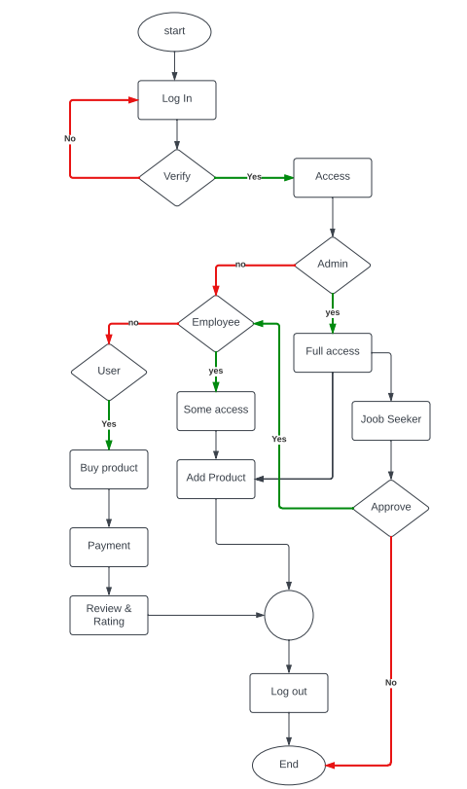

**E-R Diagram:**

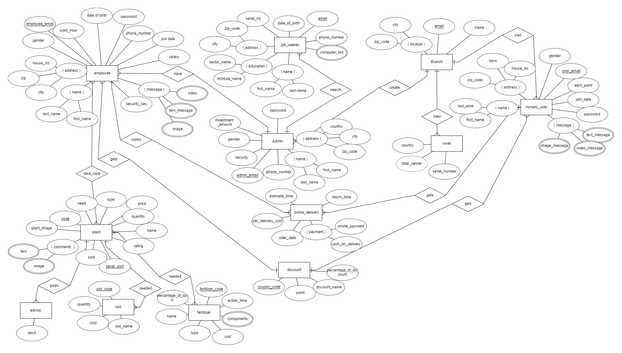

**Schematic Diagram:**

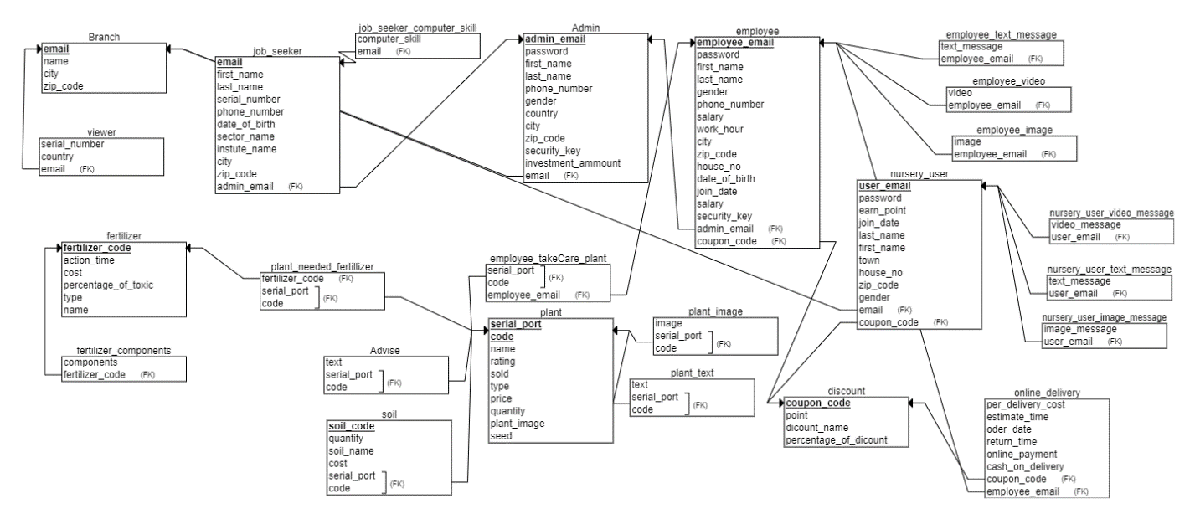

**Language & Platform:**

The database management system for the online computer accessories selling system will be developed using SQL (Structured Query Language). SQL is a standard language for managing relational databases and is widely used in the industry. It offers a simple and efficient way of managing large amounts of data and ensures data integrity and security. The project will also involve the use of programming languages such as PHP and JavaScript for the development of the front-end and back-end of the system. Platform will be XAMP

**Conclusion:**

In conclusion, Roots & Shoots is more than just a virtual marketplace for plants; it's a passionate endeavor to bring the beauty of nature into the lives of plant enthusiasts. Our commitment to providing a unique and enjoyable buying experience stems from a belief in the transformative power of plants – how they have the ability to enhance our surroundings, evoke joy, and contribute to the overall well-being of individuals.

As we navigate the path toward making the process of buying plants both seamless and delightful, we hold firm to our core values of customer delight, green lifestyle advocacy, and a commitment to education. The curated selection of high-quality plants, coupled with user-friendly interfaces and exceptional customer service, is designed to make your journey with Roots & Shoots not just transactional but truly fulfilling.

Roots & Shoots strives to be a hub of inspiration and knowledge, empowering our community with the tools they need to nurture thriving indoor gardens. We see our platform as a virtual garden where each click is an opportunity to cultivate a space that reflects the harmony between humans and nature.

Thank you for joining us on this botanical adventure. Together, let's continue to celebrate the simple joys, the beauty, and the positive impact that plants can bring into our lives. Whether you're a seasoned plant enthusiast or just starting your green journey, Roots & Shoots is here to be your companion, offering not just plants but a connection to the vibrant world of nature. Welcome to a community where the love for plants is at the heart of everything we do.